Project Design Phase-II
Data Flow Diagram & User Stories
Date | 02 July 2026
Team ID | SWTID-2026-5158
Project Name | India’s Agricultural Crop Production Analysis
Maximum Marks | 4 Marks

Data Flow Diagram
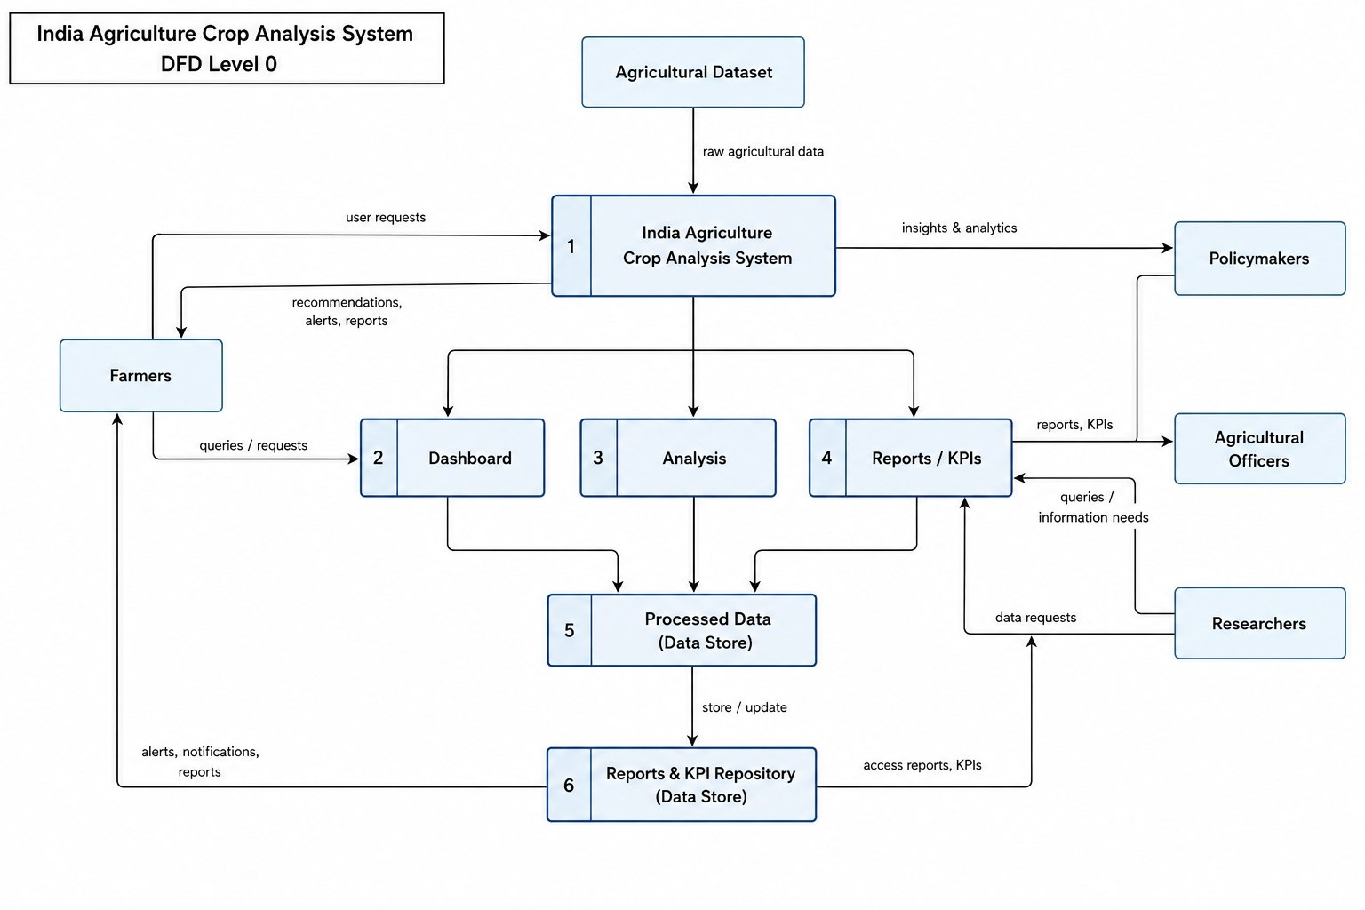

User Stories
Use the below template to list all the user stories for the product.
User Type | Functional  Requirement  (Epic) | User Story Number | User Story / Task | Acceptance criteria | Priority | Release
Farmer | Dashboard Access | USN-1 | As a farmer, I want to view state-wise cultivated areas so that I can understand agricultural land distribution. | The dashboard displays cultivated areas for all states. | High | Sprint-1
Farmer | Crop Analysis | USN-2 | As a farmer, I want to compare cultivated areas of different crops so that I can select suitable crops. | Crop-wise cultivated area visualization is available. | High | Sprint-1
Farmer | Yield Trend | USN-3 | As a farmer, I want to analyze agricultural yield trends over the years so that I can improve future crop planning. | Year-wise yield trend graph is available. | Medium | Sprint-2
Farmer | Dashboard Summary | USN-4 | As a farmer, I want to view total production and yield KPIs so that I can quickly evaluate agricultural performance. | KPI cards display total production and yield. | High | Sprint-1
Farmer | Production analysis | USN-5 | As a farmer, I want to view state-wise agricultural production so that I can identify high-performing regions. | State-wise production dashboard is displayed. | High | Sprint-1
Policymaker | Production analysis | USN-6 | As a policymaker, I want to analyze agricultural production across different states so that I can allocate resources effectively. | Acceptance Criteria State-wise comparison dashboard is available. | High | Sprint-2
Agricultural Officer | Yield Trend | USN-7 | As an agricultural officer, I want to identify crop production trends so that I can provide better recommendations to farmers. | Crop-wise and season-wise analysis is available. | Medium | Sprint-2

